**DEPARTMENT OF COMPUTER & SOFTWARE ENGINEERING**

**COLLEGE OF E&ME, NUST, RAWALPINDI**

**Subject Name**

**Digital Image Processing**

**Lab Number**

**4**

**SUBMITTED TO:**

**Dr. Asad Khan**

**LE Sundas Ashraf**

**SUBMITTED BY:**

**Student Name**

1. Wahaaj Nasir

**Reg#413238**

**DE- 44 Dept C&SE**

**Objectives:**

Filtering on Images and Histogram Calculations

**Related Topic/Chapter in theory class:**

Spatial Filtering

**Hardware/Software required:**

Hardware: PC

Software Tool: Pycharm

**Task 1:**

**Apply contrast stretching on the image provided by setting 5th and 95th percentiles of the input values to 0 and 255 respectively. The remaining values will be stretched as: *N*𝑒𝑤 𝑉𝑎𝑙𝑢𝑒 𝑓𝑜𝑟 𝑃𝑖𝑥𝑒𝑙 = 255 ∗ (𝐶𝑢𝑟𝑟𝑒𝑛𝑡 𝑣𝑎𝑙𝑢𝑒 𝑓𝑜𝑟 𝑃𝑖𝑥𝑒𝑙 − 5𝑡ℎ 𝑃𝑒𝑟𝑐𝑒𝑛𝑡𝑖𝑙𝑒) / (95𝑡ℎ 𝑃𝑒𝑟𝑐𝑒𝑛𝑡𝑖𝑙𝑒 − 5𝑡ℎ 𝑃𝑒𝑟𝑐𝑒𝑛𝑡𝑖𝑙𝑒)**

**Solution:**

import cv2 as cv  
import numpy as np  
  
def contrast_stretch(image):  
 im_min_5 = np.percentile(image, 5)  
 im_max_95 = np.percentile(image, 95)  
 rows,cols = image.shape  
 new_img = np.zeros((rows, cols), dtype = np.uint8)  
  
 for i in range(rows):  
 for j in range(cols):  
 if(image[i][j] < im_min_5):  
 new_img[i][j] = 0  
 elif(image[i][j] > im_max_95):  
 new_img[i][j] = 255  
 else:  
 new_img[i][j] = 255 * ((image[i][j] - im_min_5) / (im_max_95 - im_min_5))  
  
 return new_img  
  
  
*#---------------------------------  
# Main*image = cv.imread("D:/Uni/Semester 6/DIP/Self/Lab/Lab 4/Lab 4/low_con.jpg", 0)  
cont_img = contrast_stretch(image)  
  
cv.imshow('Original Image', image)  
cv.imshow('Contrast Image', cont_img)  
cv.waitKey()

**Output:**

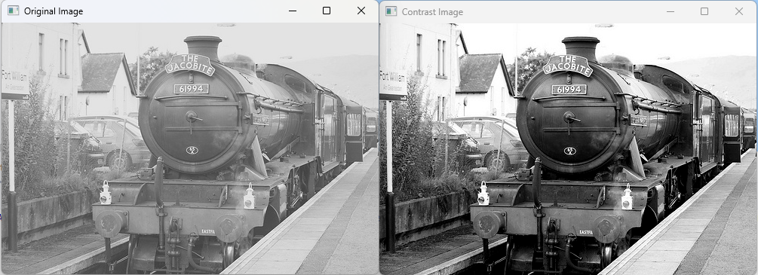

**Task 2:**

**Perform the following steps to do Hist. equalization to enhance the grayscale image.**

* **Calculate the histogram of the image and display it using the appropriate command.**

**(Don’t use the built in function of OpenCV or Numpy or Matplotlib etc.)**

* **Calculate probability density function (PDF) from the histogram and display it using the appropriate command PDF = H/(R*C). Where H is the Histogram and R and C is the number of Rows and Columns of the image respectively.**
* **Calculate cumulative PDF and display it using the appropriate command.**
* **Multiply the Cumulative PDF with 255 to find the transformation function then display it too using the appropriate command.**
* **From the transformation function, replace the gray levels of the image to create contrast enhanced (histogram equalized) image.**
* **Display the enhanced image.**

**Solution**

import cv2 as cv  
import numpy as np  
import matplotlib.pyplot as plt  
  
def histogram_creating(image):  
 rows, cols = image.shape  
 histogram = np.zeros(256, dtype = int)  
  
 for i in range(rows):  
 for j in range(cols):  
 val = image[i][j]  
 histogram[val] += 1  
  
 return histogram  
  
def calc_pdf(histogram, image):  
 rows, cols = image.shape  
  
 histogram = histogram/(rows*cols)  
  
 return histogram  
  
def calc_cum_pdf(pdf):  
 cum_pdf = np.zeros(len(pdf), dtype = float)  
 cum_pdf[0] = pdf[0]  
 for i in range(1, len(pdf)):  
 cum_pdf[i] = cum_pdf[i-1] + pdf[i]  
  
 return cum_pdf  
  
def transformation_fun(cum_pdf):  
 return np.uint8((cum_pdf*255))  
  
def apply_trans(image, trans_fun):  
 rows, cols = image.shape  
 new_img = np.zeros((rows, cols), dtype = np.uint8)  
  
 for i in range(rows):  
 for j in range(cols):  
 new_img[i][j] = trans_fun[image[i][j]]  
  
 return new_img  
  
*# ---------------------------------  
# Main*image = cv.imread("D:/Uni/Semester 6/DIP/Self/Lab/Lab 4/Lab 4/fig05.tif", 0)  
cv.imshow('Original Image', image)  
cv.waitKey()  
histogram = histogram_creating(image)  
  
plt.plot(histogram)  
plt.xlabel('Pixel Indices')  
plt.ylabel('Pixel Count')  
plt.title('Histogram')  
plt.show()  
  
pdf = calc_pdf(histogram, image)  
plt.plot(pdf)  
plt.xlabel('Pixel Indices')  
plt.ylabel('Pixel Intensity')  
plt.title('Probability Density Function')  
plt.show()  
  
cum_pdf = calc_cum_pdf(pdf)  
plt.plot(cum_pdf)  
plt.xlabel('Pixel Indices')  
plt.ylabel('Pixel Intensity')  
plt.title('Cumulative PDF')  
plt.show()  
  
transformation_function = transformation_fun(cum_pdf)  
plt.plot(transformation_function)  
plt.xlabel('Pixel Indices')  
plt.ylabel('Pixel Count')  
plt.title('Transformation Function')  
plt.show()  
  
print(transformation_function)  
  
equilized_img = apply_trans(image, transformation_function)  
cv.imshow('Enhanced Image', equilized_img)  
cv.waitKey()

**Output:**

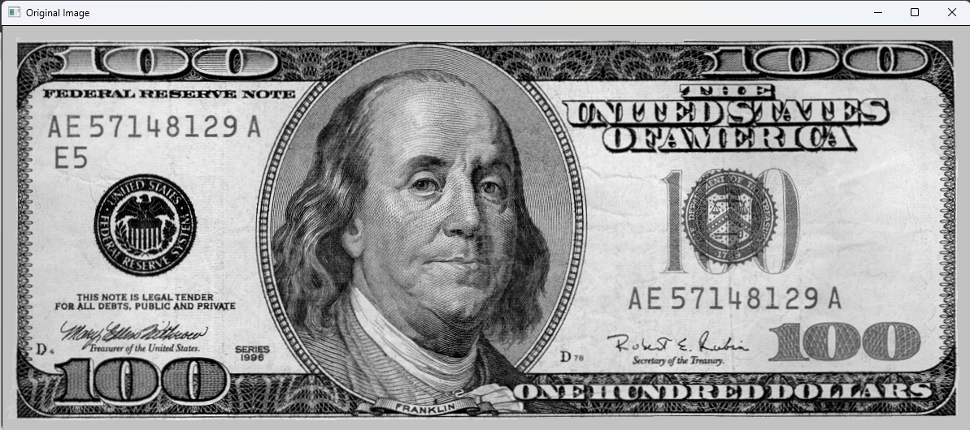

**Original Image**

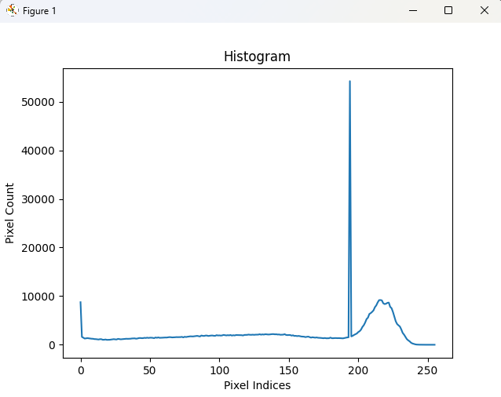

**Histogram**

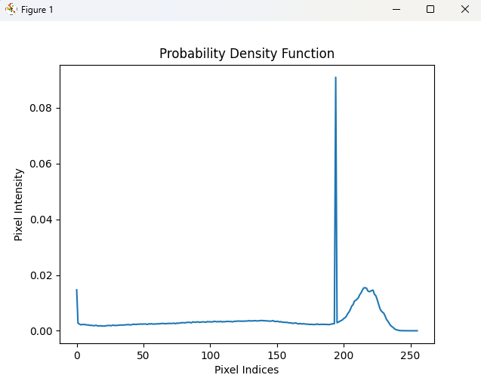

**Probability Density Function**

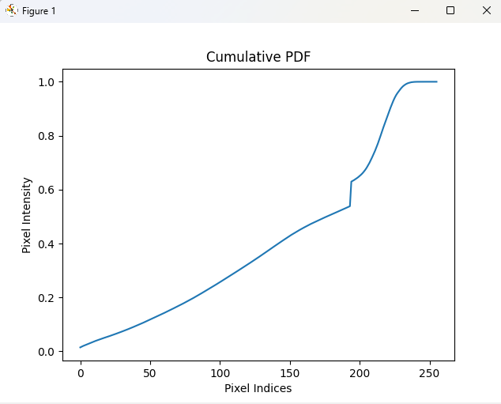

**Cumulative PDF**

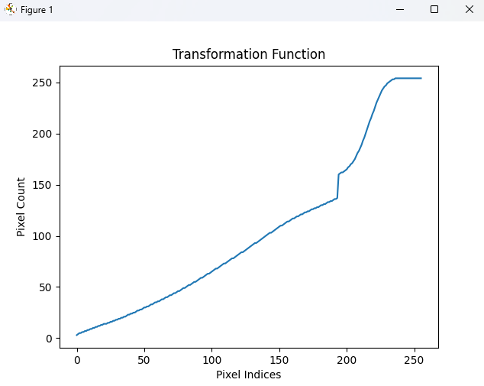

**Transformation Function**

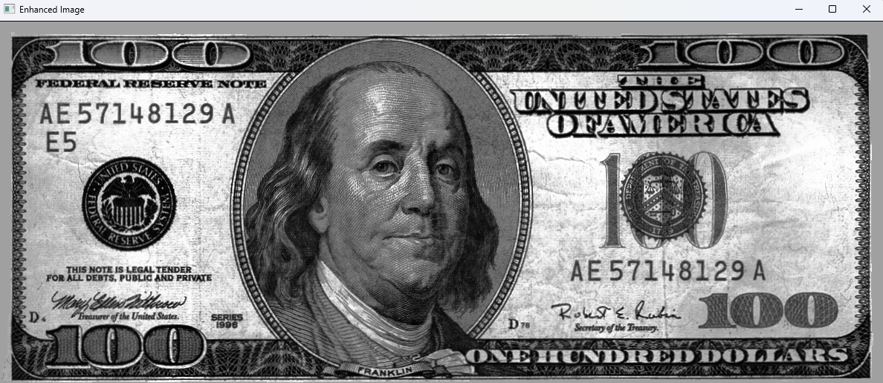

**Low Contrast Image**

**Task 3:**

**Write a generic function that takes a mask of a specific size from and applies it to an image.**

**Create the following masks and apply it to an image and display the results. The fiter will**

**nxn size. You can use fig05.tif for this task.**

**Solution**

import cv2 as cv  
import numpy as np  
  
def padding(pad, orig):  
 rows, cols = orig.shape  
 padded_arr = np.ones((rows+ 2 * pad, cols+ 2 * pad), dtype = np.uint8)*255  
  
 for i in range(rows):  
 for j in range(cols):  
 padded_arr[i+pad][j+pad] = orig[i][j]  
  
 return padded_arr  
  
def remove_padding(padded_img, pad):  
 rows, cols = padded_img.shape  
 return padded_img[pad:rows-pad, pad:cols-pad]  
  
def filter(image, filter_size, filter_var):  
 pad = filter_size//2  
 rows, cols = image.shape  
 filtered_img = np.zeros((rows, cols), dtype = np.uint8)  
  
 padded_img = padding(pad, filtered_img)  
 for i in range(pad, rows-pad):  
 for j in range(pad, cols-pad):  
 sub_img = image[i-pad:i+pad+1, j-pad:j+pad+1]  
 sub_img = np.multiply(sub_img, filter_var)  
 sub_img_val = np.sum(sub_img)  
  
 padded_img[i][j] = sub_img_val  
  
 filtered_img = remove_padding(padded_img, pad)  
  
 return filtered_img  
  
*# ----------------------------------  
# Main*image = cv.imread("D:/Uni/Semester 6/DIP/Self/Lab/Lab 4/Lab 4/fig05.tif", 0)  
cv.imshow('Original Image', image)  
cv.waitKey()  
  
filtered = filter(image, 3, 1/9)  
cv.imshow('Filtered Image', filtered)  
cv.waitKey()

**Output:**

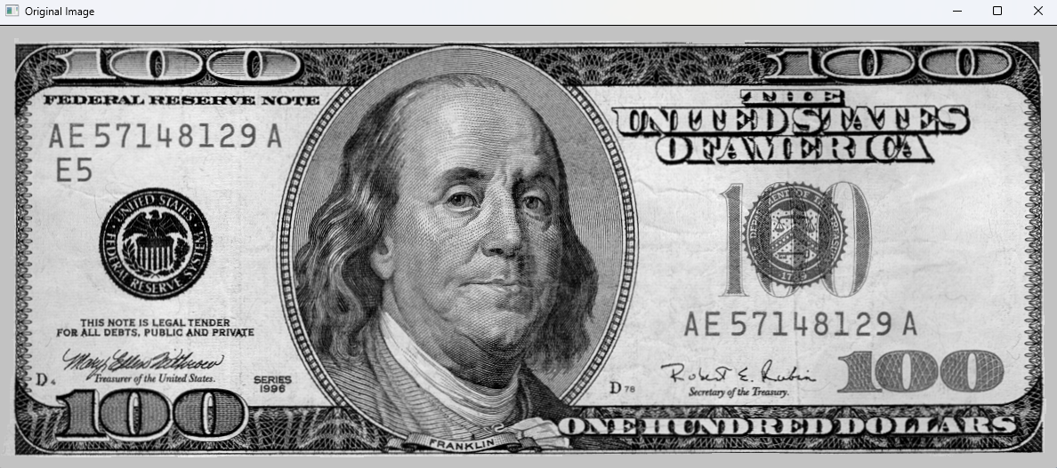

**Original Image**

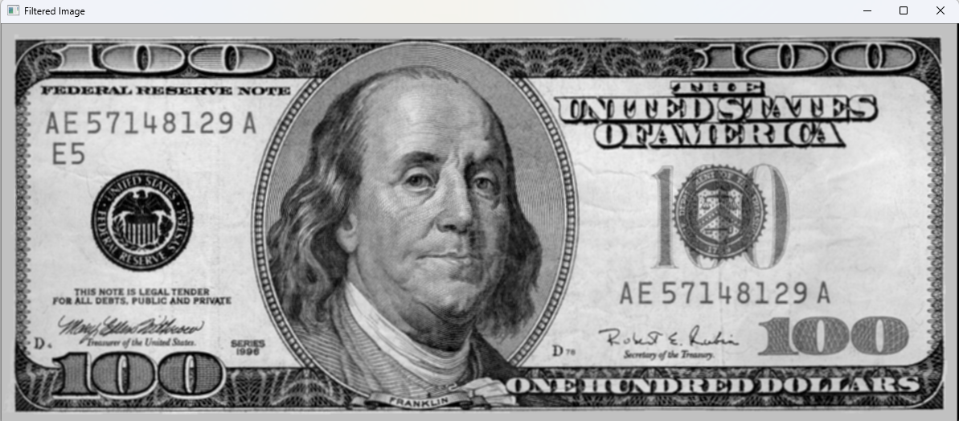

**Log Transform**